**Front-End UI/UX Mini Project**

**1. Title Page**

* **Project Title**: Digital Business Card
* **Submitted By**: 
  + 1. Name: Christa Fijo

Roll number: 2460351

Email-id: [christa.fijo@btech.christuniversity.in](mailto:christa.fijo@btech.christuniversity.in)

* + 1. Name: Tanya Jaison

Roll number: 2460459

Email-id: [tanya.jaison@btech.christuniversity.in](mailto:tanya.jaison@btech.christuniversity.in)

* + 1. Name: Fariha Sheriff

Roll number: 2460366

Email-id: [fariha.sheriff@btech.christuniversity.in](mailto:fariha.sheriff@btech.christuniversity.in)

* **Course**: UI/UX Design Fundamentals
* **Instructor Name**: Ms. Nagaveena
* **Institution**:Christ University
* **Date of Submission**: 13-08-2025

**2. Abstract**

This project focuses on creating a single-page digital business card using HTML and CSS. The card showcases a professional profile image, name, title, short bio, and interactive buttons linking to email, LinkedIn, and portfolio pages. A QR code is also integrated for instant contact sharing. The goal was to design a clean, centered layout with minimal styling and smooth hover animations. By implementing responsive design principles, the card adapts seamlessly to both desktop and mobile devices. The final output serves as a quick, accessible, and visually appealing introduction for networking purposes.

**3. Objectives**

* Create a visually striking and compact self-introduction.
* Implement CSS positioning and hover animations for interactivity.
* Ensure mobile-first responsiveness.
* Apply personal branding in UI design.

**4. Scope of the Project**

* Front-end only: HTML and CSS.
* Single-page structure with main card, contact links, and footer.
* QR code integration for quick contact saving.
* Designed for desktop, tablet, and mobile viewports.

**5. Tools & Technologies Used**

|  |  |
| --- | --- |
| Tool/Technology | Purpose |
| HTML5 | Markup and content structure |
| CSS3 | Styling and layout management |
| VS Code | Code editor |
| Chrome DevTools | Testing and debugging |
| QR Code Generator | Creating the contact QR |

**6. HTML Structure Overview**

* <main> element containing the profile card.
* <img> tag for profile image.
* <h1> and <h2> for name and title.
* <p> for bio text.
* <a> tags styled as buttons for contact links.
* <footer> for copyright notice.

**7. CSS Styling Strategy**

* External stylesheet style.css.
* Flexbox for centered layout.
* Absolute/relative positioning for elements inside the card.
* CSS transform and transition for hover animations (button scale effects).
* One accent color for branding consistency.

**8. Key Features**

|  |  |
| --- | --- |
| Feature | Description |
| Minimalist Layout | Focused on clarity and branding |
| Hover Animations | Smooth scaling effects on buttons |
| QR Code Integration | Instant contact sharing |
| Mobile Responsiveness | Scales seamlessly on all devices |

**9. Challenges Faced & Solutions**

|  |  |
| --- | --- |
| Challenge | Solution |
| Maintaining alignment across screen sizes | Used flexbox and media queries |
| Image distortion | Applied object-fit: cover |
| Button hover lag on mobile | Optimized transitions and reduced duration |

**10. Outcome**

A clean, professional digital business card that can be shared instantly via link or QR code, ensuring accessibility and strong first impressions in both online and in-person networking.

**11. Future Enhancements**

* Add a light/dark mode toggle.
* Include animated background effects.
* Integrate social media icons for quick access.

**12. Sample Code**

Index.html

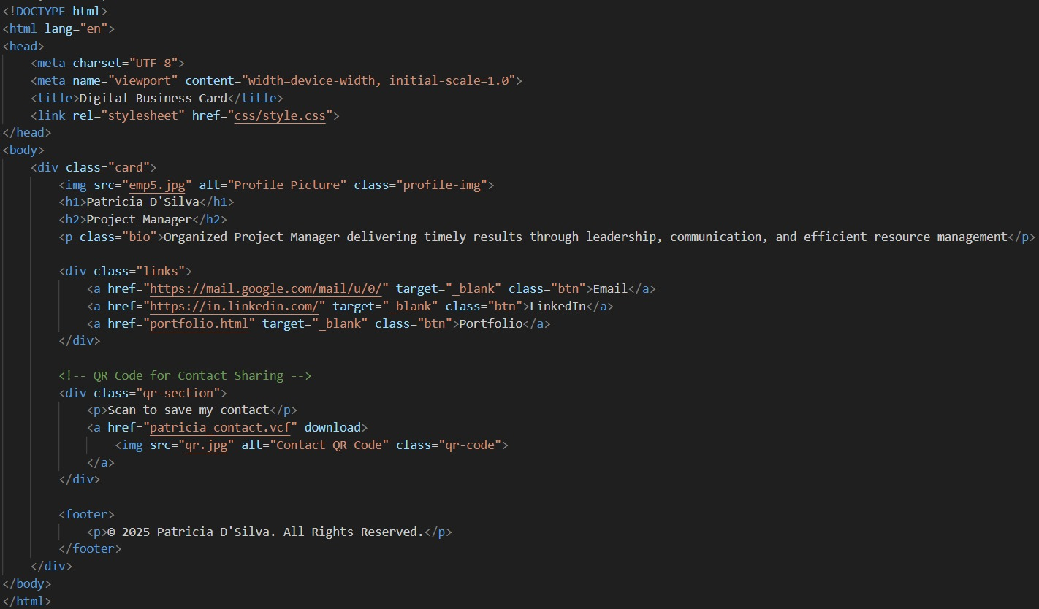

Style.css

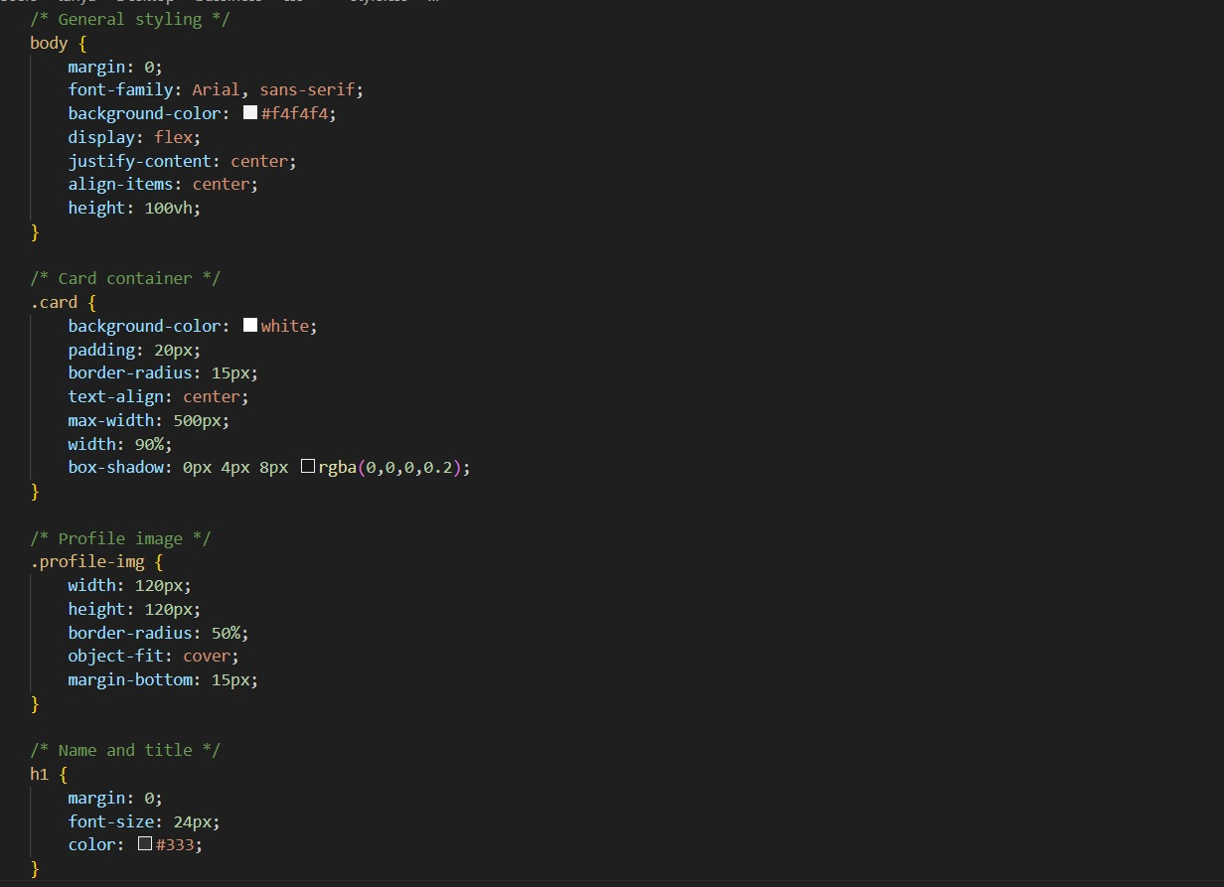

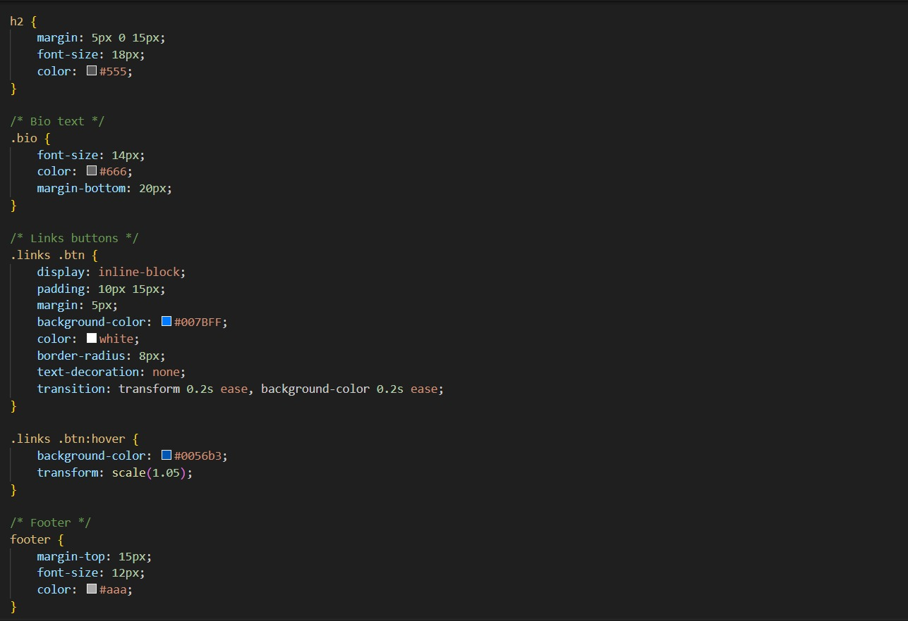



Portfolio.html

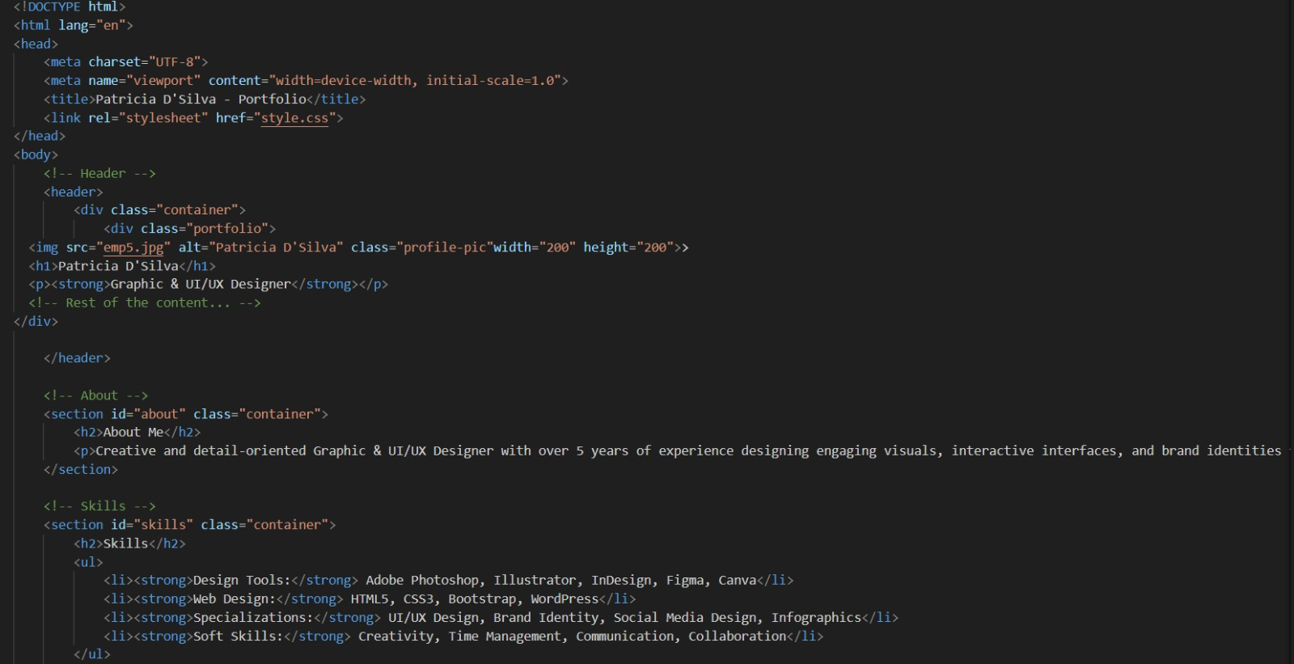

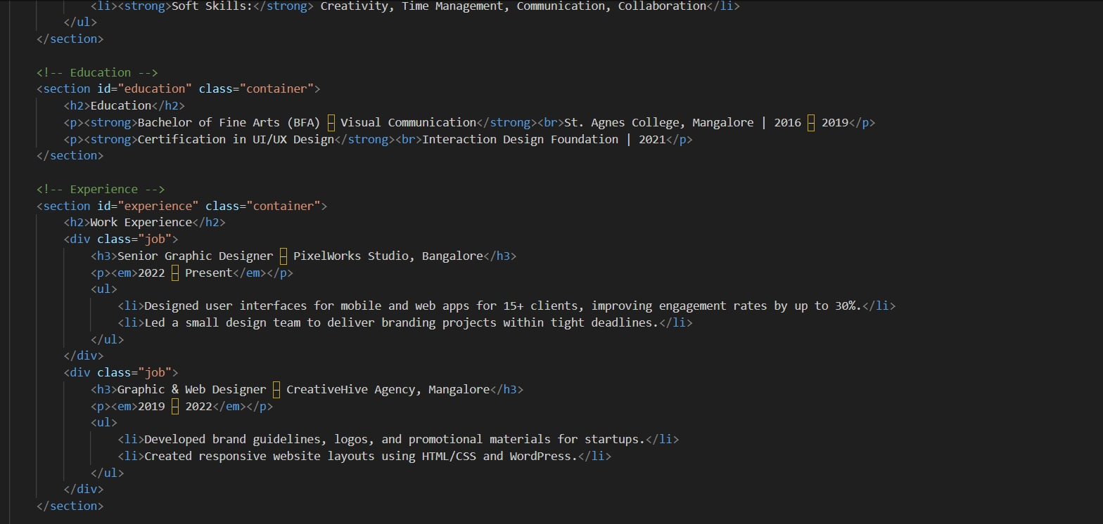

Portfolio.css

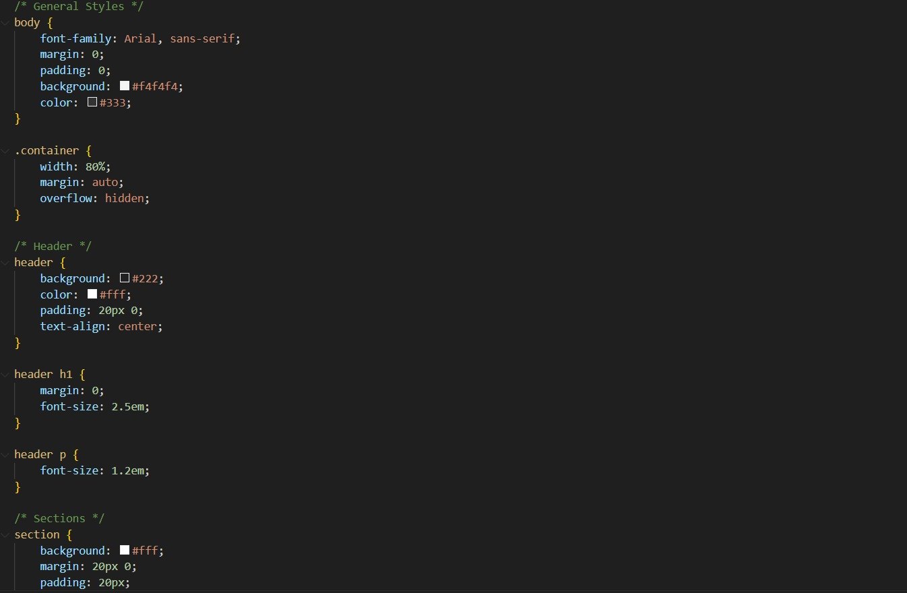

**13. Screenshots of Final Output**

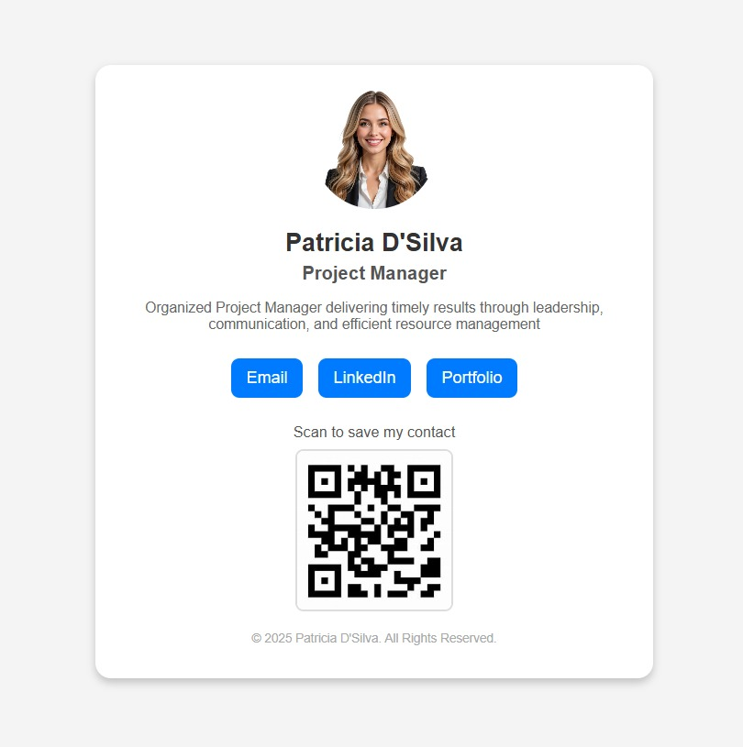

Email:

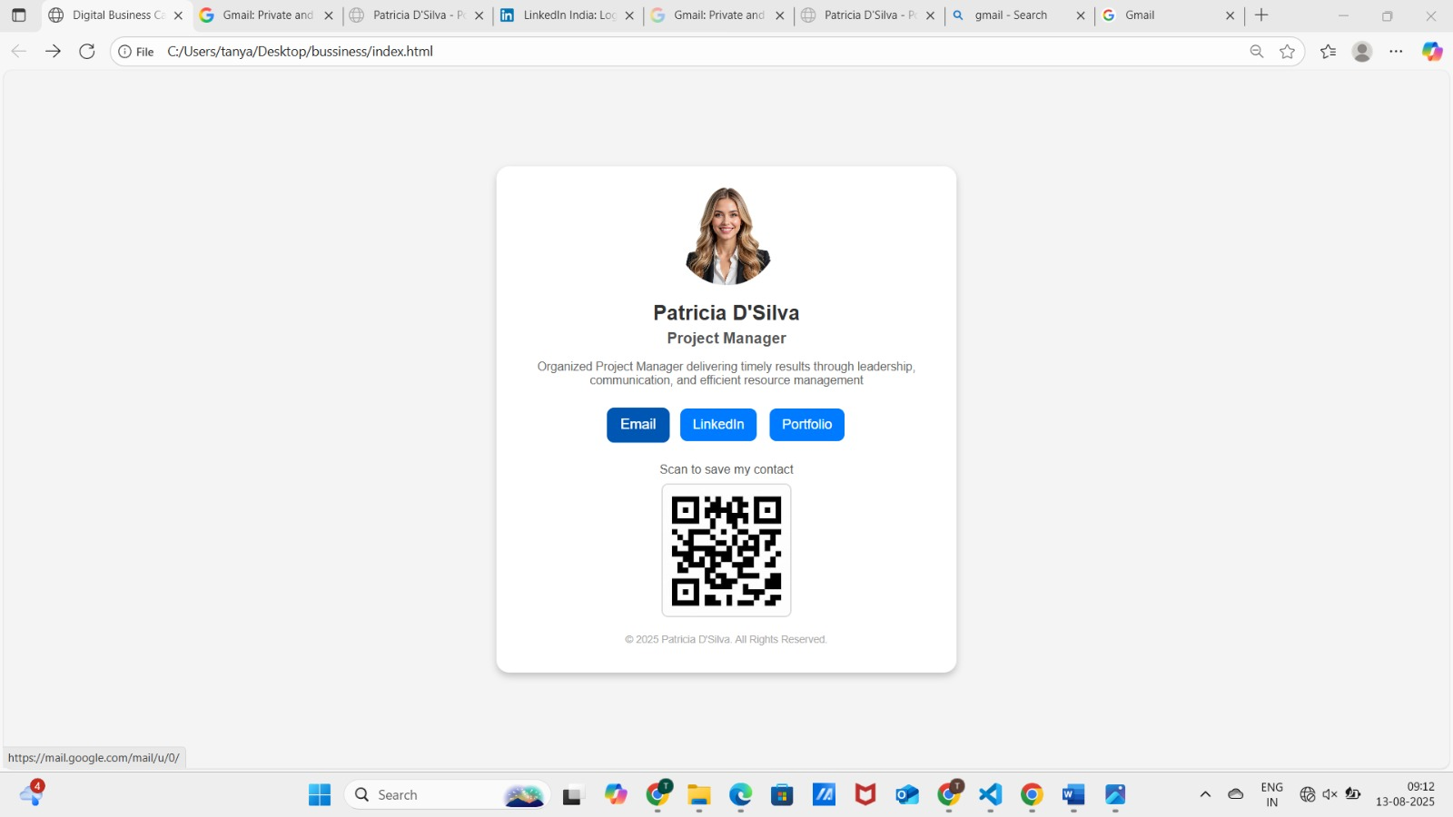

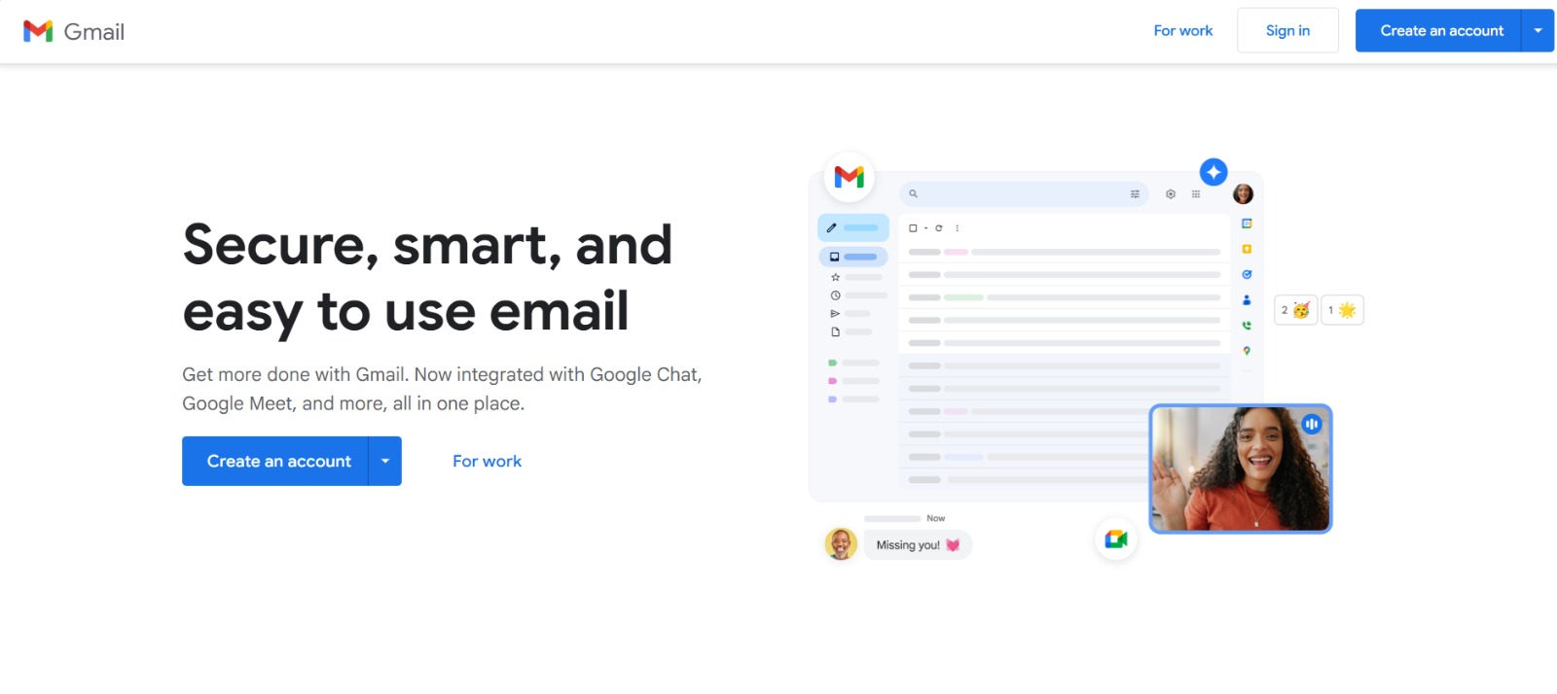

LinkedIn:

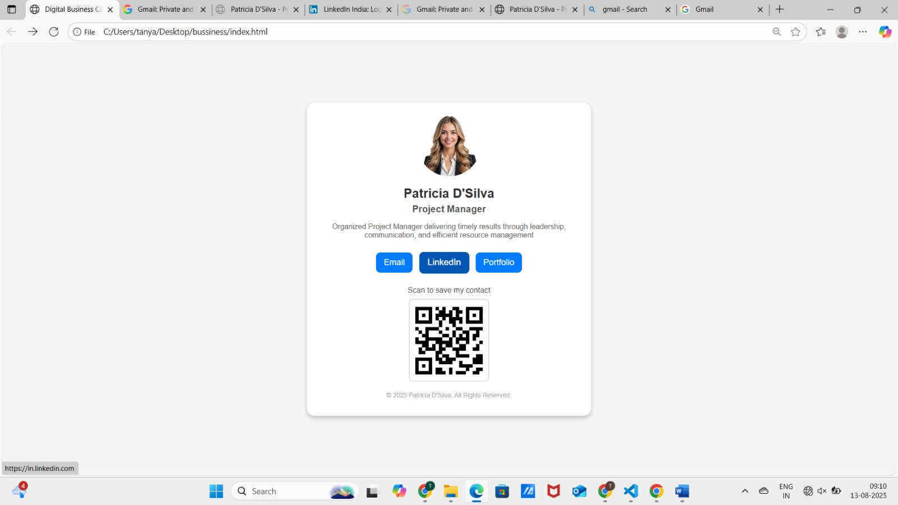

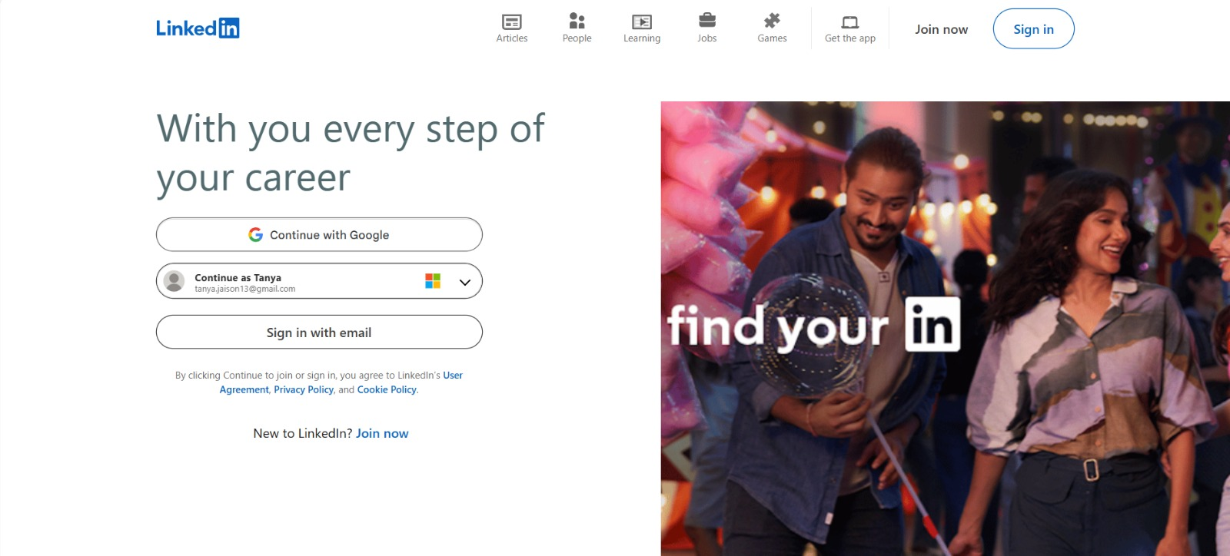

Portfolio:

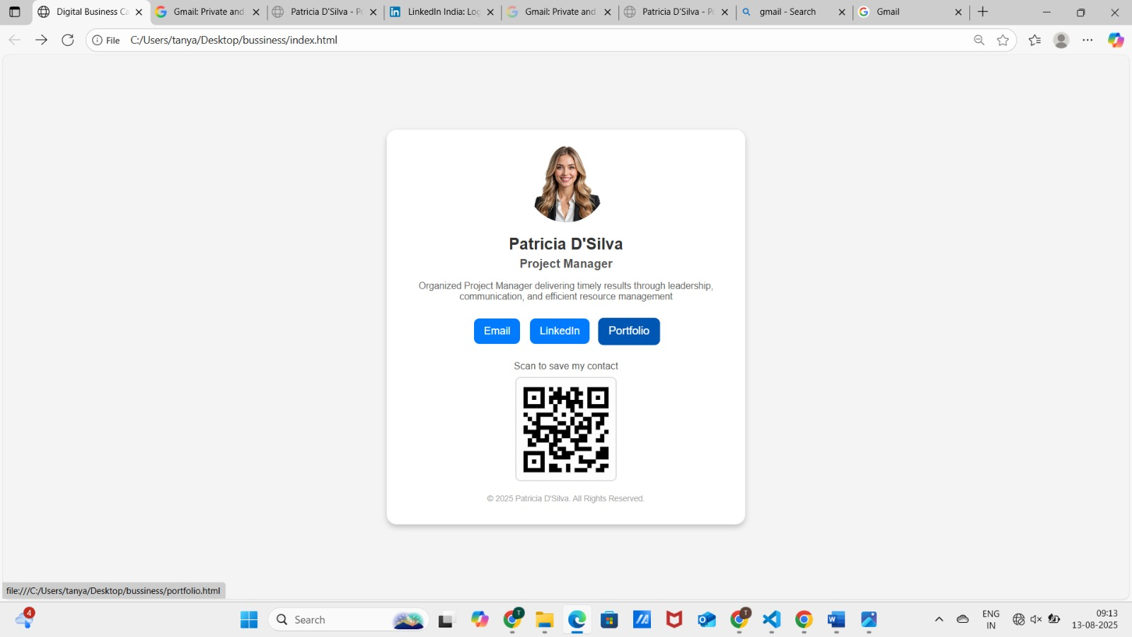

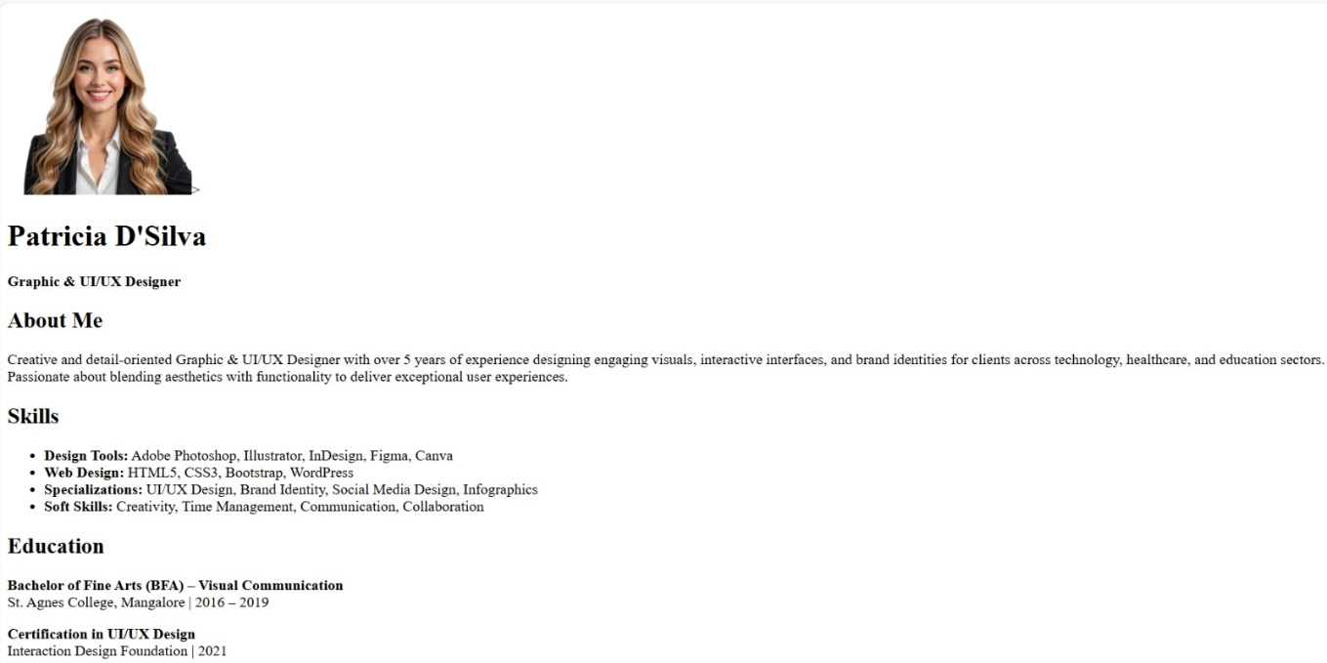

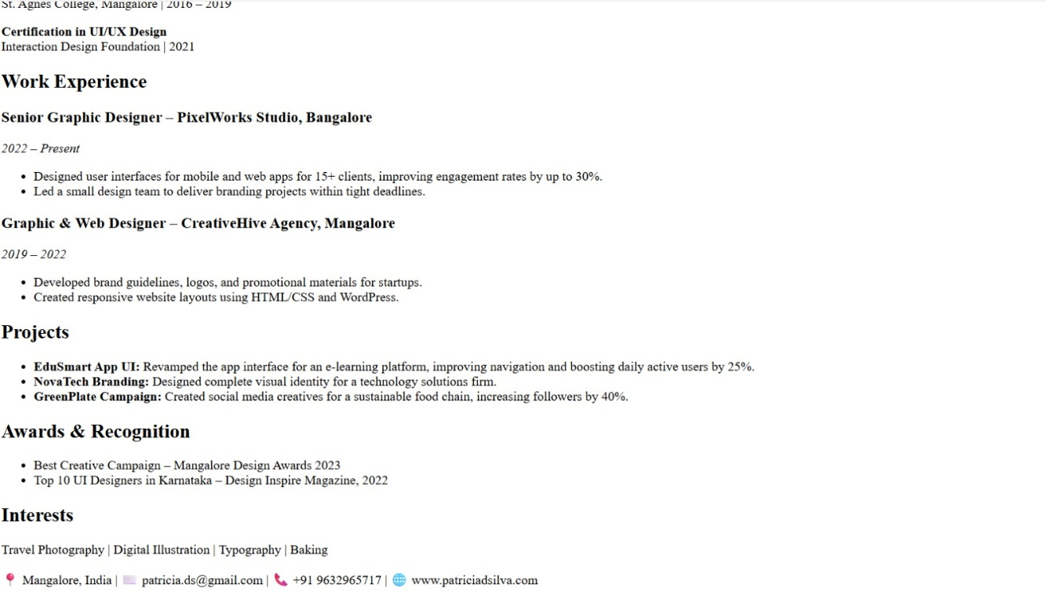

**11. Conclusion**

This project strengthened my HTML and CSS skills by combining structured layout techniques, responsive design, and smooth UI animations. The minimalist yet functional business card demonstrates how personal branding can be effectively delivered in a compact digital format.

**12. References**

* L&T LMS: <https://learn.lntedutech.com/Landing/MyCourse>